

A Project Report

On

**“Online Inspection of Packed Cases”**

Batch Details

|  |  |  |
| --- | --- | --- |
| Sl. No. | Roll Number | Student Name |
| 1 | 20211CSE0845 | B HARINATH REDDY |
| 2 | 20211CSE0709 | K DINESH |
| 3 | 20211CSE0516 | D SAI ESWARA REDDY |
| 4 | 20211CSE0838 | D LAKSHMI NIRANJAN REDDY |
| 5 | 20211CSE0839 | N PAVAN KUMAR |

**School of Computer Science,**

**Presidency University, Bengaluru.**

Under the guidance of,

Dr./Mr./Ms. Prof. Sukruth Gowda

Professor/ Associate Professor/ Assistant Professor

School of Computer Science,

Presidency University, Bengaluru

**CONTENTS**

1. Introduction about Project
2. Literature Review
3. Objectives

## Methodology

1. Timeline for Execution of Project
2. Expected Outcomes
3. Conclusion
4. References
5. **INTRODUCTION**

In the agricultural industry, quality control plays a crucial role in maintaining customer satisfaction and ensuring compliance with product standards. The specific focus of this project is on the inspection of packed cases containing threshed crop leaves, each weighing approximately 200 kg. Currently, the inspection process is manual, with only 10% of the cases being evaluated for quality parameters such as color, ripeness, and uniformity. This manual process relies heavily on the subjective judgment of experts, which introduces several limitations, including inconsistency, inefficiency, and delays in feedback.

Manual inspection methods are highly dependent on human expertise, making them prone to errors and variability. Factors such as fatigue, environmental conditions, and individual judgment can lead to inconsistent assessments. Additionally, the current approach allows for only partial inspection coverage due to constraints in manpower and time. This results in many cases bypassing quality control, increasing the risk of defective products reaching customers.

The limitations of the manual process also extend to operational efficiency. Inspections are performed a day after production, limiting the ability to take corrective actions in real time. As a result, deviations in product quality may persist unaddressed, leading to potential dissatisfaction among customers and economic losses for the business. Furthermore, scaling up manual inspection to achieve 100% coverage is impractical due to the associated costs and logistical challenges.

To address these issues, this project proposes an automated inspection system that leverages Artificial Intelligence (AI) and image processing technologies. By utilizing advanced AI models and industrial-grade imaging systems, the project aims to replace the subjective manual process with an objective, consistent, and efficient solution. This system will perform real-time inspections, enabling immediate identification and correction of quality deviations. Additionally, it ensures 100% inspection coverage, reducing the likelihood of defective products reaching customers.

The integration of AI and image processing into the inspection workflow offers numerous benefits. These include improved accuracy, faster processing times, and the elimination of human bias. The system is designed to analyze key quality parameters and compare them against predefined standards, ensuring that each packed case conforms to customer expectations. Furthermore, real-time analytics and feedback mechanisms will facilitate proactive quality control, enhancing operational efficiency and overall product reliability.

This project is a significant step toward modernizing quality control practices in the agricultural sector. By addressing the limitations of manual inspection and leveraging state-of-the-art technologies, it aims to deliver a scalable, efficient, and reliable solution that meets the demands of both producers and customers. The implementation of this system will not only improve product quality but also set a benchmark for innovation in the industry.

**2. LITERATURE REVIEW**

Manual inspection and traditional automation methods are commonly used for quality control in industrial applications. However, each approach comes with its own advantages and limitations. Below is an analysis of existing methods related to the problem statement:

**Advantages of Existing Methods:**

1. **Low Initial Cost (Manual Inspection):** Manual inspection requires minimal upfront investment in terms of technology or equipment.
2. **Human Intuition:** Trained experts can detect subtle quality defects that may not be easily identified by automated systems.
3. **Flexibility:** Manual methods can adapt to varying product types and quality standards without requiring significant adjustments.
4. **Proven Effectiveness:** Traditional manual and semi-automated systems have been used successfully in many industries for decades.
5. **Low Maintenance (Manual Systems):** Compared to automated systems, manual processes require less maintenance.
6. **Immediate Deployment:** Human inspectors can be quickly trained and deployed, making this method suitable for short-term or low-volume operations.

**Limitations (Disadvantages) of Existing Methods:**

1. **Subjectivity in Judgment:** Human inspection is inherently inconsistent, as judgments can vary between individuals based on experience, fatigue, and environmental factors.
2. **Limited Coverage:** Due to manpower constraints, only a fraction of cases (e.g., 10%) can be inspected, leaving the majority unchecked.
3. **Delayed Feedback:** Inspections often occur after production, leading to delays in corrective actions.
4. **Error-prone:** Human errors can result in defective cases being incorrectly classified as conforming.
5. **Labor-intensive:** Manual inspection requires significant human resources, making it expensive and inefficient for large-scale operations.
6. **Scalability Issues:** Scaling up manual inspection processes is challenging due to increased labor costs and logistical constraints.
7. **Inconsistent Standards:** Quality judgments can vary due to differing levels of expertise and external pressures.
8. **Slow Throughput:** Human inspection processes are slower compared to automated systems, reducing overall production efficiency.
9. **Environmental Impact:** Manual systems often require high energy and resource consumption to support human operations, including lighting and air conditioning in inspection areas.
10. **Inability to Provide Real-time Feedback:** Traditional methods cannot provide instant insights, which are essential for proactive quality control.

These limitations highlight the need for an automated solution that addresses the shortcomings of existing methods while leveraging their advantages where possible.

**3. OBJECTIVES**

1. **Develop an Automated Quality Inspection System:** Design and implement an AI-driven system to address the subjectivity and inconsistency of manual inspection processes.
2. **Achieve Comprehensive Inspection Coverage:** Ensure 100% inspection of all packed cases to eliminate the limitations of selective sampling and undetected defects.
3. **Enable Real-time Feedback Mechanisms:** Integrate real-time analytics and alert systems to provide immediate feedback for corrective actions during production.
4. **Enhance Scalability and Operational Efficiency:** Create a solution that can be scaled to handle increasing production volumes without a proportional increase in operational costs.
   1. **EXPERIMENTAL DETAILS/METHDOLOGY**

**Hardware Used:**

* + 1. High-resolution industrial cameras for capturing images of the packed cases.
    2. Adequate lighting setups to ensure consistent image quality.
    3. High-performance GPU for training AI models.

**Software Used:**

* + 1. **Data Annotation Tools:** LabelImg, CVAT, or VoTT for preparing training datasets.
    2. **Backend Frameworks:** Flask or Django for deploying the AI model.
    3. **Database Management:** PostgreSQL or MongoDB for storing inspection data and results.
    4. **Deployment Platforms:** Docker for containerization, AWS or Google Cloud for scalability.
    5. **Edge Devices:** NVIDIA Jetson or Raspberry Pi for real-time on- premise analysis.

**Methodology :**

**Step 1: Image Acquisition**

High-resolution industrial cameras are installed along the conveyor belt to capture images of each packed case as it passes through. Adequate lighting setups ensure consistent image quality.

**Step 2: Image Preprocessing**

Captured images are preprocessed using OpenCV to normalize brightness, reduce noise, and enhance features. Techniques such as histogram equalization and edge detection are applied to prepare the images for analysis.

**Step 3: Feature Extraction**

Pretrained deep learning models like ResNet and MobileNet are used to extract key features from the images. These features include color distribution, texture uniformity, and visual cues related to ripeness.

**Step 4: Classification**

Using the extracted features, the AI model classifies the cases as either conforming or non-conforming to predefined quality standards. This classification is based on thresholds derived from the master case approved by the customer.

**Step 5: Deployment**

The trained model is deployed on an edge device, such as NVIDIA Jetson, to enable real-time processing on the factory floor. A backend system built using Flask or Django supports data storage and analytics.

**Step 6: Real-time Feedback**

The system flags defective cases in real-time and triggers alerts for immediate corrective action. This feedback loop minimizes delays in addressing quality issues.

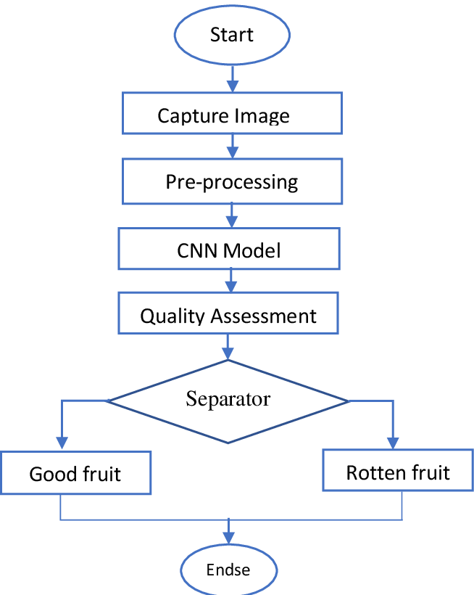

**5. OUTCOMES**

1. **Comprehensive Inspection:** 100% inspection of packed cases, ensuring all products meet quality standards.
2. **Improved Accuracy:** AI-driven classification ensures consistent and objective quality assessments.
3. **Real-time Feedback:** Instant identification of defective cases enables on-the-spot corrective actions.
4. **Operational Efficiency:** Automation reduces dependency on manual labor, lowering costs and increasing throughput.
5. **Customer Satisfaction:** Enhanced product quality and reliability lead to better customer experiences.

**6. TIMELINE OF THE PROJECT/ PROJECT EXECUTION PLAN**

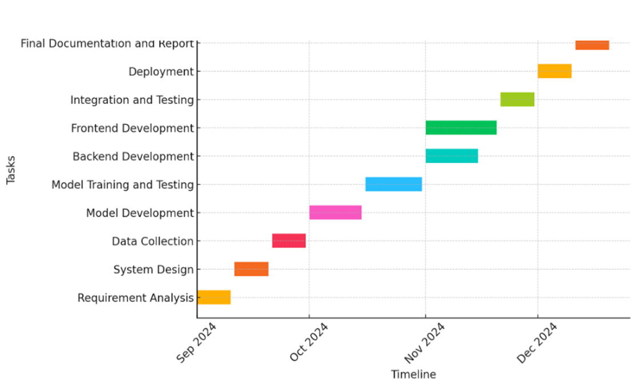

1. **CONCLUSION**

In conclusion, the proposed project to leverage Artificial Intelligence (AI) and image processing for the online inspection of packed cases offers a transformative solution to existing challenges in quality control. By addressing the limitations of manual inspection processes—such as subjectivity, inconsistency, and limited coverage—this innovative approach ensures that every packed case undergoes a thorough and objective evaluation. This transition from manual to automated inspection is not merely a technological upgrade but a strategic move towards operational excellence and enhanced customer satisfaction.

The AI-driven system ensures 100% inspection coverage, enabling businesses to identify and address quality deviations in real time. This capability minimizes the risks associated with defective products, reduces the dependency on human expertise, and streamlines the overall quality control process. The integration of real-time feedback mechanisms further empowers production teams to make immediate corrections, thereby maintaining high standards of quality and reducing potential wastage. Additionally, the scalability of this system ensures its applicability to varying production volumes, making it a versatile solution for industries of all sizes.

One of the most significant outcomes of this project is the elimination of human bias and subjectivity in quality assessments. By relying on predefined standards and AI algorithms, the system guarantees consistent and accurate results, fostering trust and reliability among customers. Moreover, the use of advanced image processing techniques ensures that even minute defects are detected, further enhancing the credibility of the inspection process.

From an economic perspective, the automation of quality control processes translates into cost savings in the long term. Reduced labor dependency, faster throughput, and minimized product returns contribute to improved profitability. Furthermore, the adoption of cutting-edge technologies positions the business as a forward-thinking and innovative entity, capable of meeting the evolving demands of the market.

In a broader context, this project underscores the potential of AI and image processing to revolutionize traditional industrial practices. By seamlessly integrating technology into operational workflows, businesses can achieve unprecedented levels of efficiency and accuracy. This initiative not only addresses the immediate challenges of quality control but also sets a precedent for future innovations in the agricultural and manufacturing sectors.

Ultimately, the successful implementation of this project will lead to enhanced product quality, greater customer satisfaction, and a competitive edge in the marketplace. It serves as a testament to the transformative power of technology and its role in shaping the future of industry. The journey from manual to automated inspection marks a significant milestone in quality control practices, paving the way for smarter, more efficient, and reliable operations.

**REFERENCES**

* Russakovsky, O., Deng, J., Su, H., et al. (2015). "ImageNet Large Scale Visual Recognition Challenge." *International Journal of Computer Vision*, 115(3), 211-252.
* **LeCun, Y., Bengio, Y., & Hinton, G. (2015).** "Deep Learning." Nature, 521(7553), 436-444.
* **Zhang, X., Li, Z., and Cai, Y. (2019).** "Image Processing Techniques for Quality Inspection in Manufacturing." IEEE Transactions on Industrial Electronics, 66(7), 5079-5090.
* **Redmon, J., Divvala, S., Girshick, R., & Farhadi, A. (2016).** "You Only Look Once: Unified, Real-Time Object Detection." Proceedings of the IEEE Conference on Computer Vision and Pattern Recognition (CVPR).
* **Zhou, Z., Sohn, S., & Peng, Y. (2021).** "Real-Time Edge AI for Industrial Quality Inspection." IEEE Internet of Things Journal, 8(9), 7012-7024.
* ISO 9001:2015 Quality Management Systems – Requirements.
* **Goodfellow, I., Bengio, Y., & Courville, A. (2016).** "Deep Learning." MIT Press.
* **Nguyen, H., Valiveti, S., and Ramachandran, S. (2020).** "AI in Quality Control: Industrial Applications and Case Studies." Journal of Manufacturing Systems, 57, 366-380.
* **Regattieri, A., Gamberi, M., & Manzini, R. (2007).** "Traceability of Food Products: General Framework and Experimental Evidence." Journal of Food Engineering.